Collaboration with SYSU-Medicine

**Introduction**

The core method to treat IBD in our project is utilizing the peptide EGF secreted by our engineered bacteria to repair colons of patients. In order to prove the effect of this potent peptide, we collaborated with another 2016 IGEM team, SYSU-Medicine, who decided to apply MSCs therapy to cure IBD.

During the competition, we sent our purified EGF peptide expressed by our engineered bacteria to them, and they use the IBD model mice to help us prove its validity.

They referred to the article(Modeling method reference: Chemically induced mouse models of intestinal inflammation Stefan Wirtz, Clemens Neufert, Benno Weigmann & Markus F Neurath Laboratory of Immunology, I Medical Clinic, University of Mainz, Mainz, Germany. Correspondence should be addressed to M.F.N. Published online 15 March 2007; doi:10.1038/nprot.2007.41 ) and designed the following experiment:

1. Select several similar mice and weight them on the second day of fasting.

2. Choose half of them for EGF solution enema as an experiment group, and the rest of them are dealt with normal saline as the control group.

3. Weight each of them at the same time every day.

4. After the fifth day, kill all of them and measure the length of colons.

|  |  |  |  |  |  |
| --- | --- | --- | --- | --- | --- |
| sample | Day 1 | Day 2 | Day 3 | Day 4 | Day 5 |
| 1 | 20.45 | 19.64 | 18.89 | 17.63 | 17.66 |
| 2 | 19.55 | 18.31 | 18.08 | 17.98 | 18.03 |
| 3 | 22.53 | 22.01 | 22.10 | 22.49 | 23.17 |
| 4 | 23.46 | 22.98 | 22.88 | 23.36 | 23.98 |

Weight table (unit: gram)

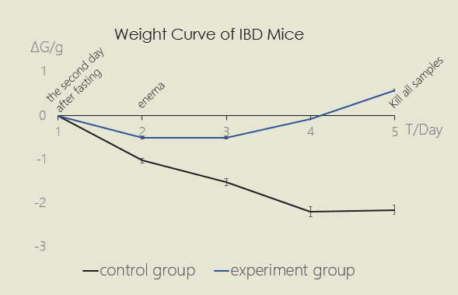

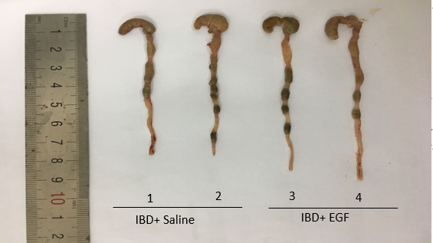

The length of colons indicates the effect of repair.

According to the evidence all above, we can draw a conclusion that our secreted EGF peptide works!